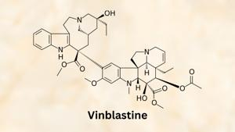
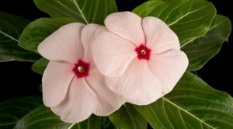
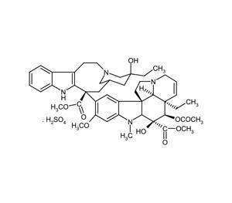
Vinblastine is a chemotherapy drug classified as a vinca alkaloid and used primarily to treat various cancers including Hodgkin's lymphoma, non-Hodgkin's lymphoma, testicular cancer, breast cancer, lung cancer, and others12347. It is commonly administered as an intravenous injection, and should only be given under the supervision of an experienced healthcare professional due to the risk of severe local tissue damage if it leaks outside the vein (extravasation)26.
Mechanism of action:
- Vinblastine works by inhibiting the polymerization of tubulin into microtubules, thereby blocking cell division at the M phase of the cell cycle57. This results in the death of rapidly dividing cancer cells.
Major clinical uses:
- Hodgkin's and non-Hodgkin’s lymphoma
- Testicular cancer
- Breast cancer (especially when other treatments have failed)
- Kaposi’s sarcoma
- Langerhans cell histiocytosis
- Some sarcomas and brain tumors1237
Side effects:
- Common: nerve changes (neuropathy), constipation, weakness, appetite loss, headaches12
- Severe: low blood cell counts (myelosuppression, especially leukopenia), increased infection risk, shortness of breath, tissue damage at injection site if extravasation occurs246
- Use during pregnancy is likely harmful to the fetus2.
Origin and chemistry:
- Vinblastine is a natural product derived from the Madagascar periwinkle (Catharanthus roseus)15. Its chemical formula is C46H58N4O93.
Important cautions:
- Do not administer if a patient has an active bacterial infection
- Not recommended during pregnancy unless absolutely necessary
- Only to be given intravenously by trained personnel due to extravasation risk26
Vinblastine remains a World Health Organization Essential Medicine due to its established utility in standard chemotherapy regimens for serious cancers1.
- https://en.wikipedia.org/wiki/Vinblastine
- https://medlineplus.gov/druginfo/meds/a682848.html
- https://go.drugbank.com/drugs/DB00570
- https://www.mayoclinic.org/drugs-supplements/vinblastine-intravenous-route/description/drg-20066688
- http://www.bccancer.bc.ca/drug-database-site/Drug%20Index/Vinblastine_monograph_1Feb2015.pdf
- https://www.cancerresearchuk.org/about-cancer/treatment/drugs/vinblastine
- https://www.cancer.gov/about-cancer/treatment/drugs/vinblastinesulfate
- https://chemocare.com/chemotherapy/drug-info/vinblastine.aspx
- https://reference.medscape.com/drug/velban-vinblastine-342096

